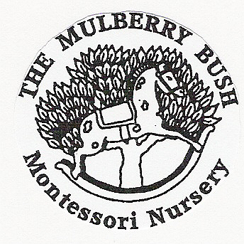
STAFF APPRAISAL POLICY

POLICY

At the Mulberry Bush we are committed to ensuring we provide high quality inclusive provision for the children in our care. The management recognises that the nursery staff are the best and most important and valued resource we can provide and ensures staff are supported in their practice and in their continual professional development.

- Appraisals will provide the opportunity for the nursery Principal and staff to have a one to one discussion with staff on things they have done well and any issues such as personal, work related problems, time keeping, attendance, performance, compliance, continual professional development, strengths, and challenges and to identify any training requirements.

- Information raised in supervision will be included in the appraisal to show an overall performance for the year and include the individual’s objectives and goals for the coming year. Supervision will provide a system to monitor performance of staff and set priorities to support or improve practice that will facilitate the annual appraisal.

- The appraisal will identify continual professional development training requirements, this may also include; coaching, mentoring, in-house training, on-line training as well as attending outside training and qualification opportunities that will support best practice and help career progression that will ensure quality provision.

This may also include;
- the individuals practice and performance
- absence

- time keeping
- time management
- work relationships
- relationships with children
- professional relationships parents and families
- working with other agencies, professionals
- continual professional development training

- Appraisals may provide the opportunity to assess an individual’s suitability for promotion and career progression and discuss salary.

- The nursery Principal will organise and schedule annual appraisals for all staff and volunteers. A mid-year review meeting may be arranged where objectives or further actions have been set.

- Any areas discussed and any agreed objectives set will be recorded. Once the appraisal has been completed the employee will have the opportunity to view the report and make any comments. Employee and the Principal will sign and date the completed appraisal document.

PROCEDURE

- Staff to complete the nursery annual appraisal document and return to the Principal.

- Principal to gather information in order to give feedback, constructive criticism where appropriate and praise successes.

- Appraisal meeting to be scheduled.

- Discussion between the nursery Principal and the employee around the information given on the appraisal document, taking into account information gathered through supervision meetings. Discussion on performance, goals and

- objectives. Develop an action plan to summarise the main points discussed and any further action required or training needs identified.

- Consider whether a mid-year review would be beneficial and should be scheduled.

February 2019

