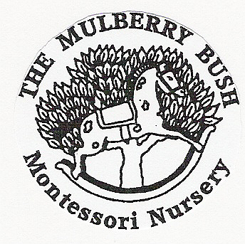
THE MULBERRY BUSH MONTESSORI NURSERY
INDUCTION POLICY

POLICY

At the Mulberry Bush we are committed to ensuring we provide high quality, inclusive provision for the children in our care. The management recognises that the nursery staff are the best and most important and valued resource we can provide and ensures staff are supported in their practice and in their continual professional development from the outset.

In order for new team members to settle into the team and their role quickly and maximise their confidence and performance we invest the time in the induction process for all new staff, long term students and volunteers that gives them a good grounding and involves all aspects of our provision. It begins on the first day of employment and continues throughout their probationary period to ensure we are maintaining high quality provision at all times. The induction may include mentoring, coaching and training.

PROCEDURE

- When a new team member is appointed following a rigorous recruitment procedure before their starting date a discussion will take place with the employee and the nursery Principal to establish and to clarify their understanding of the culture of the setting and the expectations placed on them and their role. They will be invited to spend a day with us and perhaps attend a staff meeting to meet the team and feel involved in the decision making process from the outset.

- They will be given an induction starter pack which will give information about our approach, our values and goals, the principles and aims of the nursery and the EYFS. It will provide core policies and procedures that support health and safety, child protection and safeguarding children, equality and inclusion, how we support children with SEND, and behaviour management.

- They will also be asked to complete an employment pack which provides the nursery with information regarding their suitability for employment and working with young children.

- New staff will be given key information regarding H & S, including risk assessment, evacuation procedures, safeguarding and security and a tour of the setting, introduced to the team, shown all areas and information about staff deployment to ensure they are aware of and understand their personal responsibility to ensure the children’s safety and wellbeing at all times.

- An induction check list will be put into place to ensure we have a record of all areas covered.

- Informed of nursery roles: SDP, H & S officer, SENCO - Autism Lead, Equality and Inclusion development coordinator, Speech and Language coordinator, behaviour management coordinator. Ensure all staff know how to recognise concerns and who to report any concerns to.

- They will be shown where all the fire/emergency exits are situated, firefighting equipment, whistles are located, assembly point and talked through the fire evacuation procedure.

- They will be asked to read the H & S employment poster in the kitchen and other written information posters and notices for staff.

- H & S information and ensuring they understand their personal responsibility regarding: safeguarding, fire safety, electrical equipment, cleanliness and hygiene procedures, nappy changing, risk assessment, food preparation, security, lifting and handling.

- Asked to read and understand the full welfare requirements of the EYFS and how compliance with our policies and procedures ensure we are meeting or exceeding the EYFS requirements and are compliant with current legislation and law.

- Given information regarding the learning and development requirements and guidelines of the EYFS and how we implement the requirements in practice through the Montessori Approach.

- Given time and asked to read the nursery Operational file that holds all nursery policy and procedures and supporting documents.

- Each new team member will be supported throughout their probationary period and given a mentor to support and coach them in their professional development.

- Asked to sign and date to confirm they gave read, understood and will comply with the nursery policy and procedures and supporting documents and will value and support the nursery ethos and approach.

- Book relevant training requirements identified to support CPD.

