HOLLY CRAIG

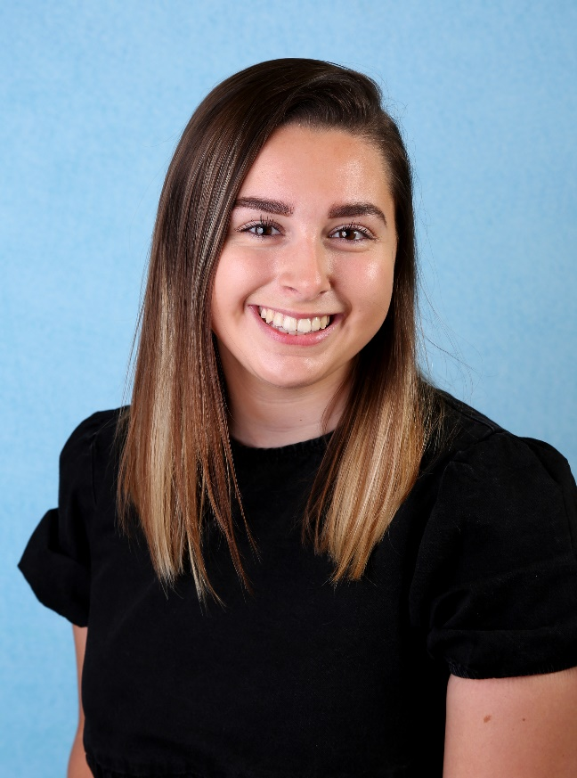
POSITION: EARLY YEARS PRACTITIONER APPRENTICE
ROLE: KEY PERSON (SUPERVISED)
QUALIFICATIONS: WORKING TOWARDS EY EDUCATOR DIPLOMA LEVEL 3

