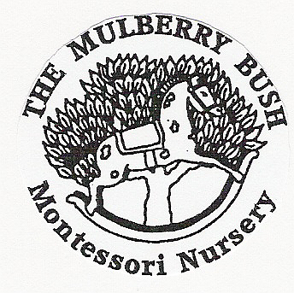
THE MULBERRY BUSH MONTESSORI NURSERY
NO NUT POLICY

The Mulberry Bush Montessori Nursery has a NO NUT POLICY in place to ensure the health and safety of everyone.

Policy
Keeping the children safe is our top priority, regular, senior staff are trained in paediatric and emergency first aid. We will work with parents, seek advice and outside training to ensure we are able to support children’s individual medical needs and keep them safe. Children that may have an intolerance or allergy to something will have a care plan in place and all staff, students and volunteers will be informed of their condition.

Procedure

Some foods that are a cause for concern are grapes, cherry tomatoes, gooseberries, olives, sliced banana; foods that are spherical and just the right size to get stuck in a child’s trachea, so to avoid a choking hazard we ask parents to cut them in half (longways). Nuts are a choking hazard too and cannot be digested easily and are therefore not recommended for children under five.

Allergies to certain foods and insect bites/stings are particularly concerning as a severe reaction can develop quickly and be life threatening. Allergies in young children are not always apparent from the start as they can develop over time through repeated exposure to the cause the symptoms progress. When a young child is first exposed to an allergen it may not cause noticeable symptoms or reaction, however the more times they are exposed to the allergen the more serious the allergic reaction can become. This is particularly the case with nuts, although other foods etc. can trigger the same reaction.
For other children they may have a severe reaction the first time they are exposed to it. When a child is allergic to nuts or eggs, they may have a severe reaction by just touching them or even being near to someone that has eaten or handled them recently.

The first signs of an allergic reaction is usually reddening, itching and/or tingling of the lips, tongue, itchy mouth, throat, this may lead to puffiness and swelling of the lips, face or affected area, which may cause breathing difficulties.

Anaphylactic shock is extremely frightening and very serious. It can escalate in a very short space of time, therefore we urge parents to help us to protect all of the children in the setting by not providing nuts or nut products in their child’s lunch box and if they do provide eggs to warn a senior member of staff so we can make sure a child with an intolerance or allergy to egg is supervised and not sat too close.

Unless we have a known allergy to nuts, we will not ban or stop supplying foods that are made in a factory that handles nuts or may have come into contact with nuts somewhere in the processing, but we will not buy foods with nuts as a direct ingredient.

With all allergies we will work closely with parents, take advice and put precautions into place as needed in individual cases.

Please help us, to help you keep your children safe

